38.25: 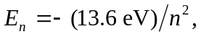 so this state has 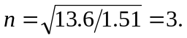 In the Bohr model.
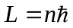 so for this state 